CS 255 System Design Document Template

This template lays out all the different sections that you need to complete for Project Two. Each section has guidance to prompt your thinking. You will need to continually reference the interview transcript as you work to make sure that you are addressing your client’s needs. There is no required length for the final document. Instead the goal is to complete each section based on what your client’s needs are. Remove this note when you are finished, and replace all bracketed text with the relevant information.

UML Diagrams

UML Use Case Diagram
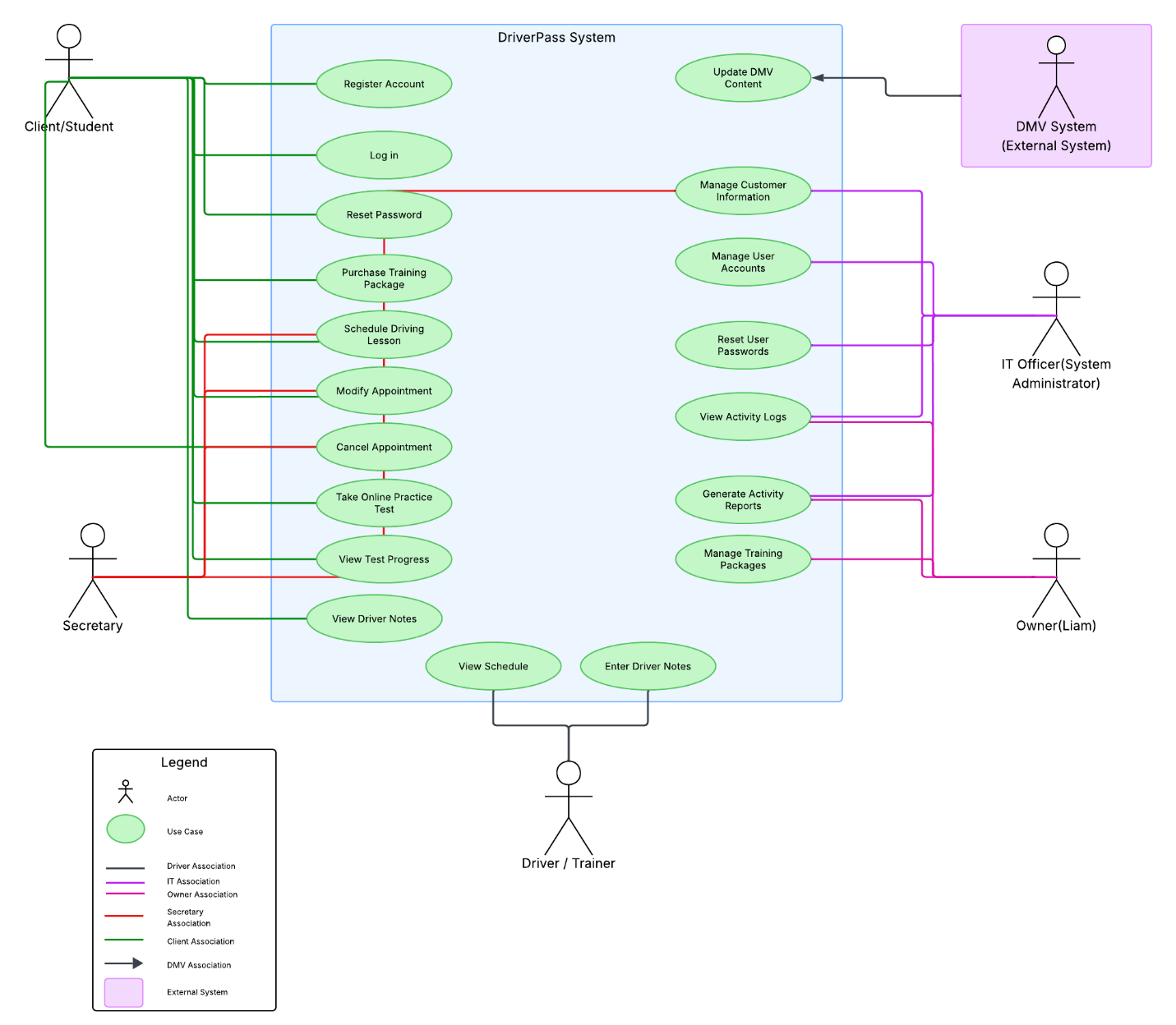

UML Activity Diagrams
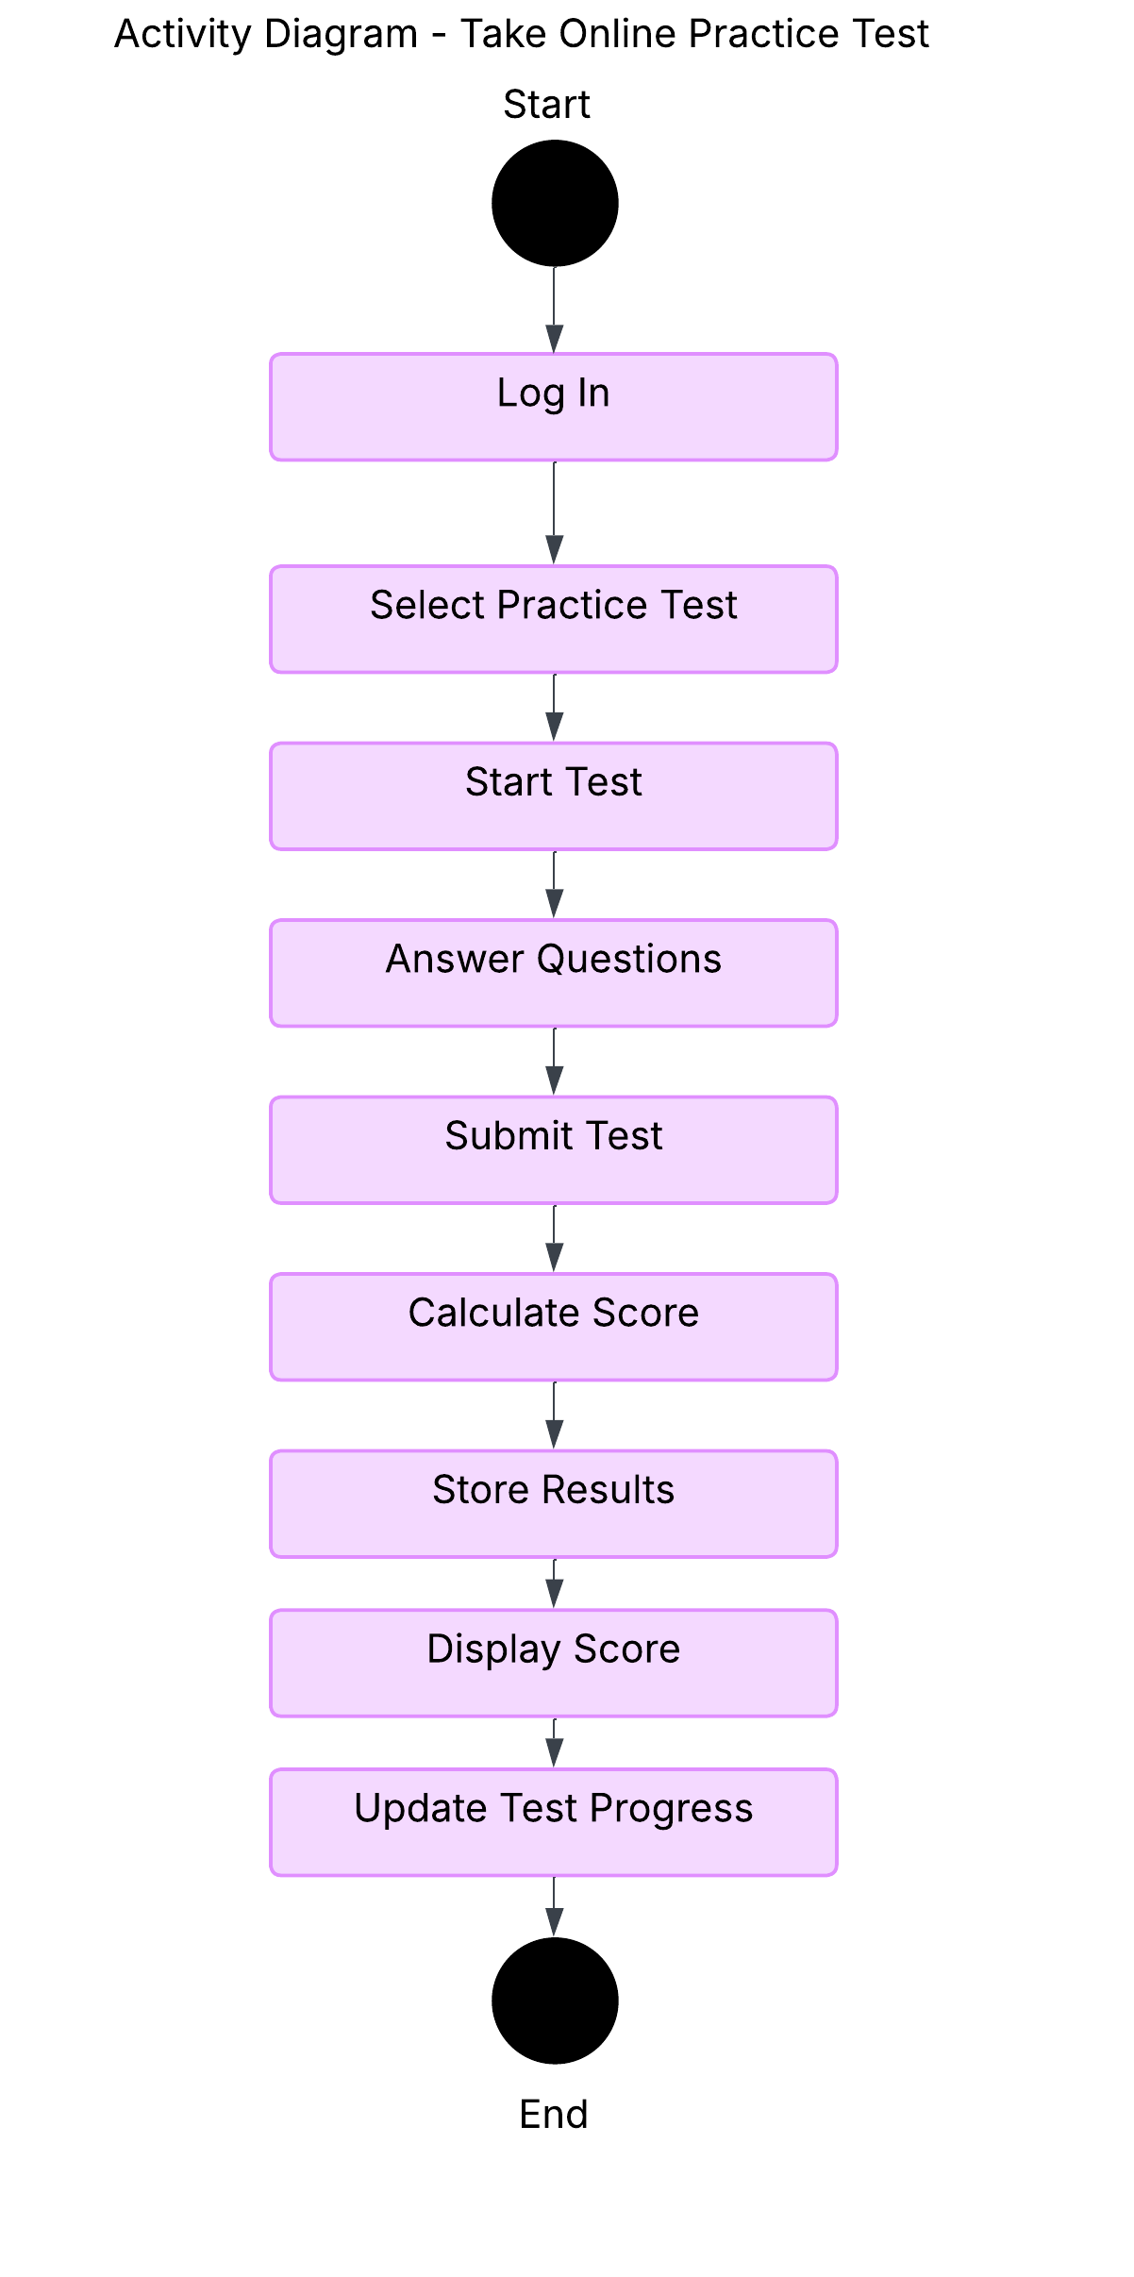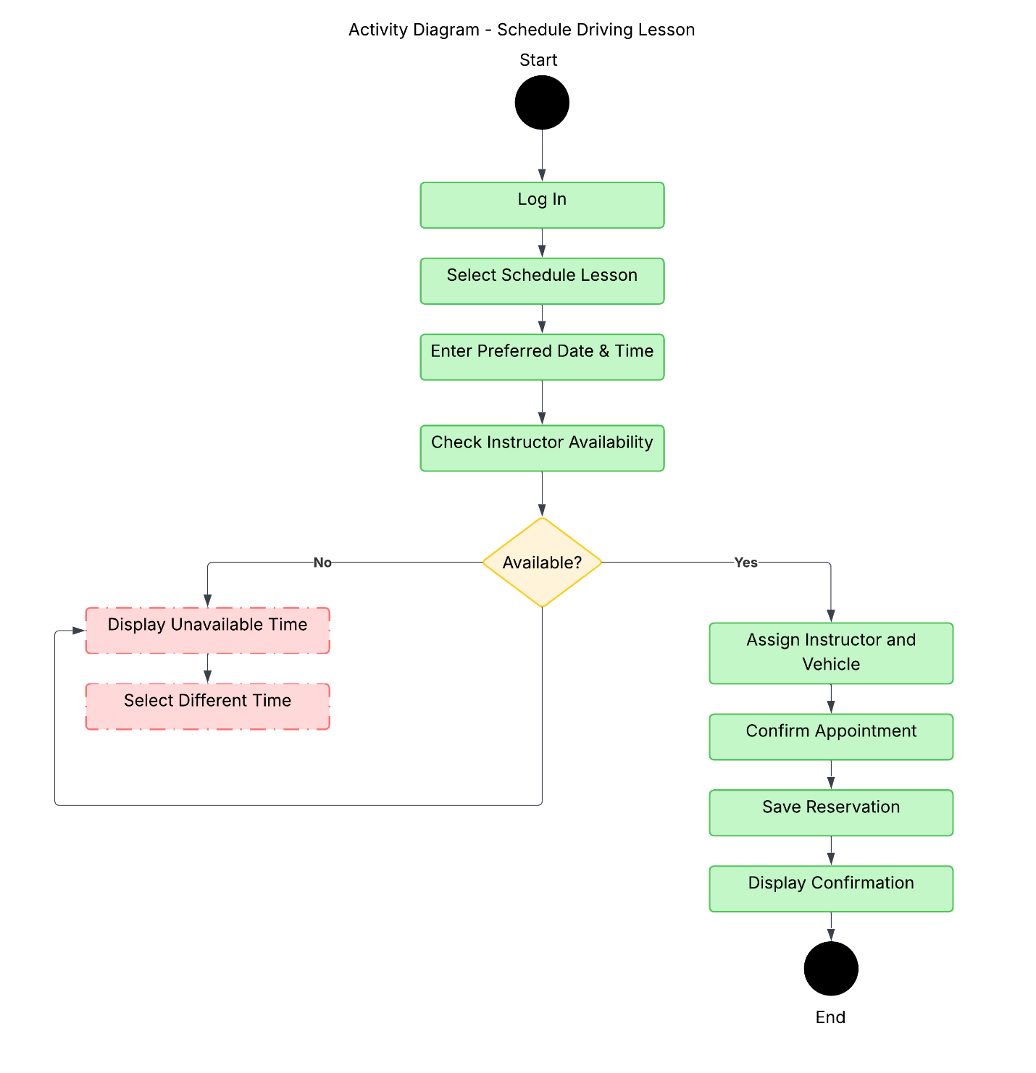

UML Sequence Diagram
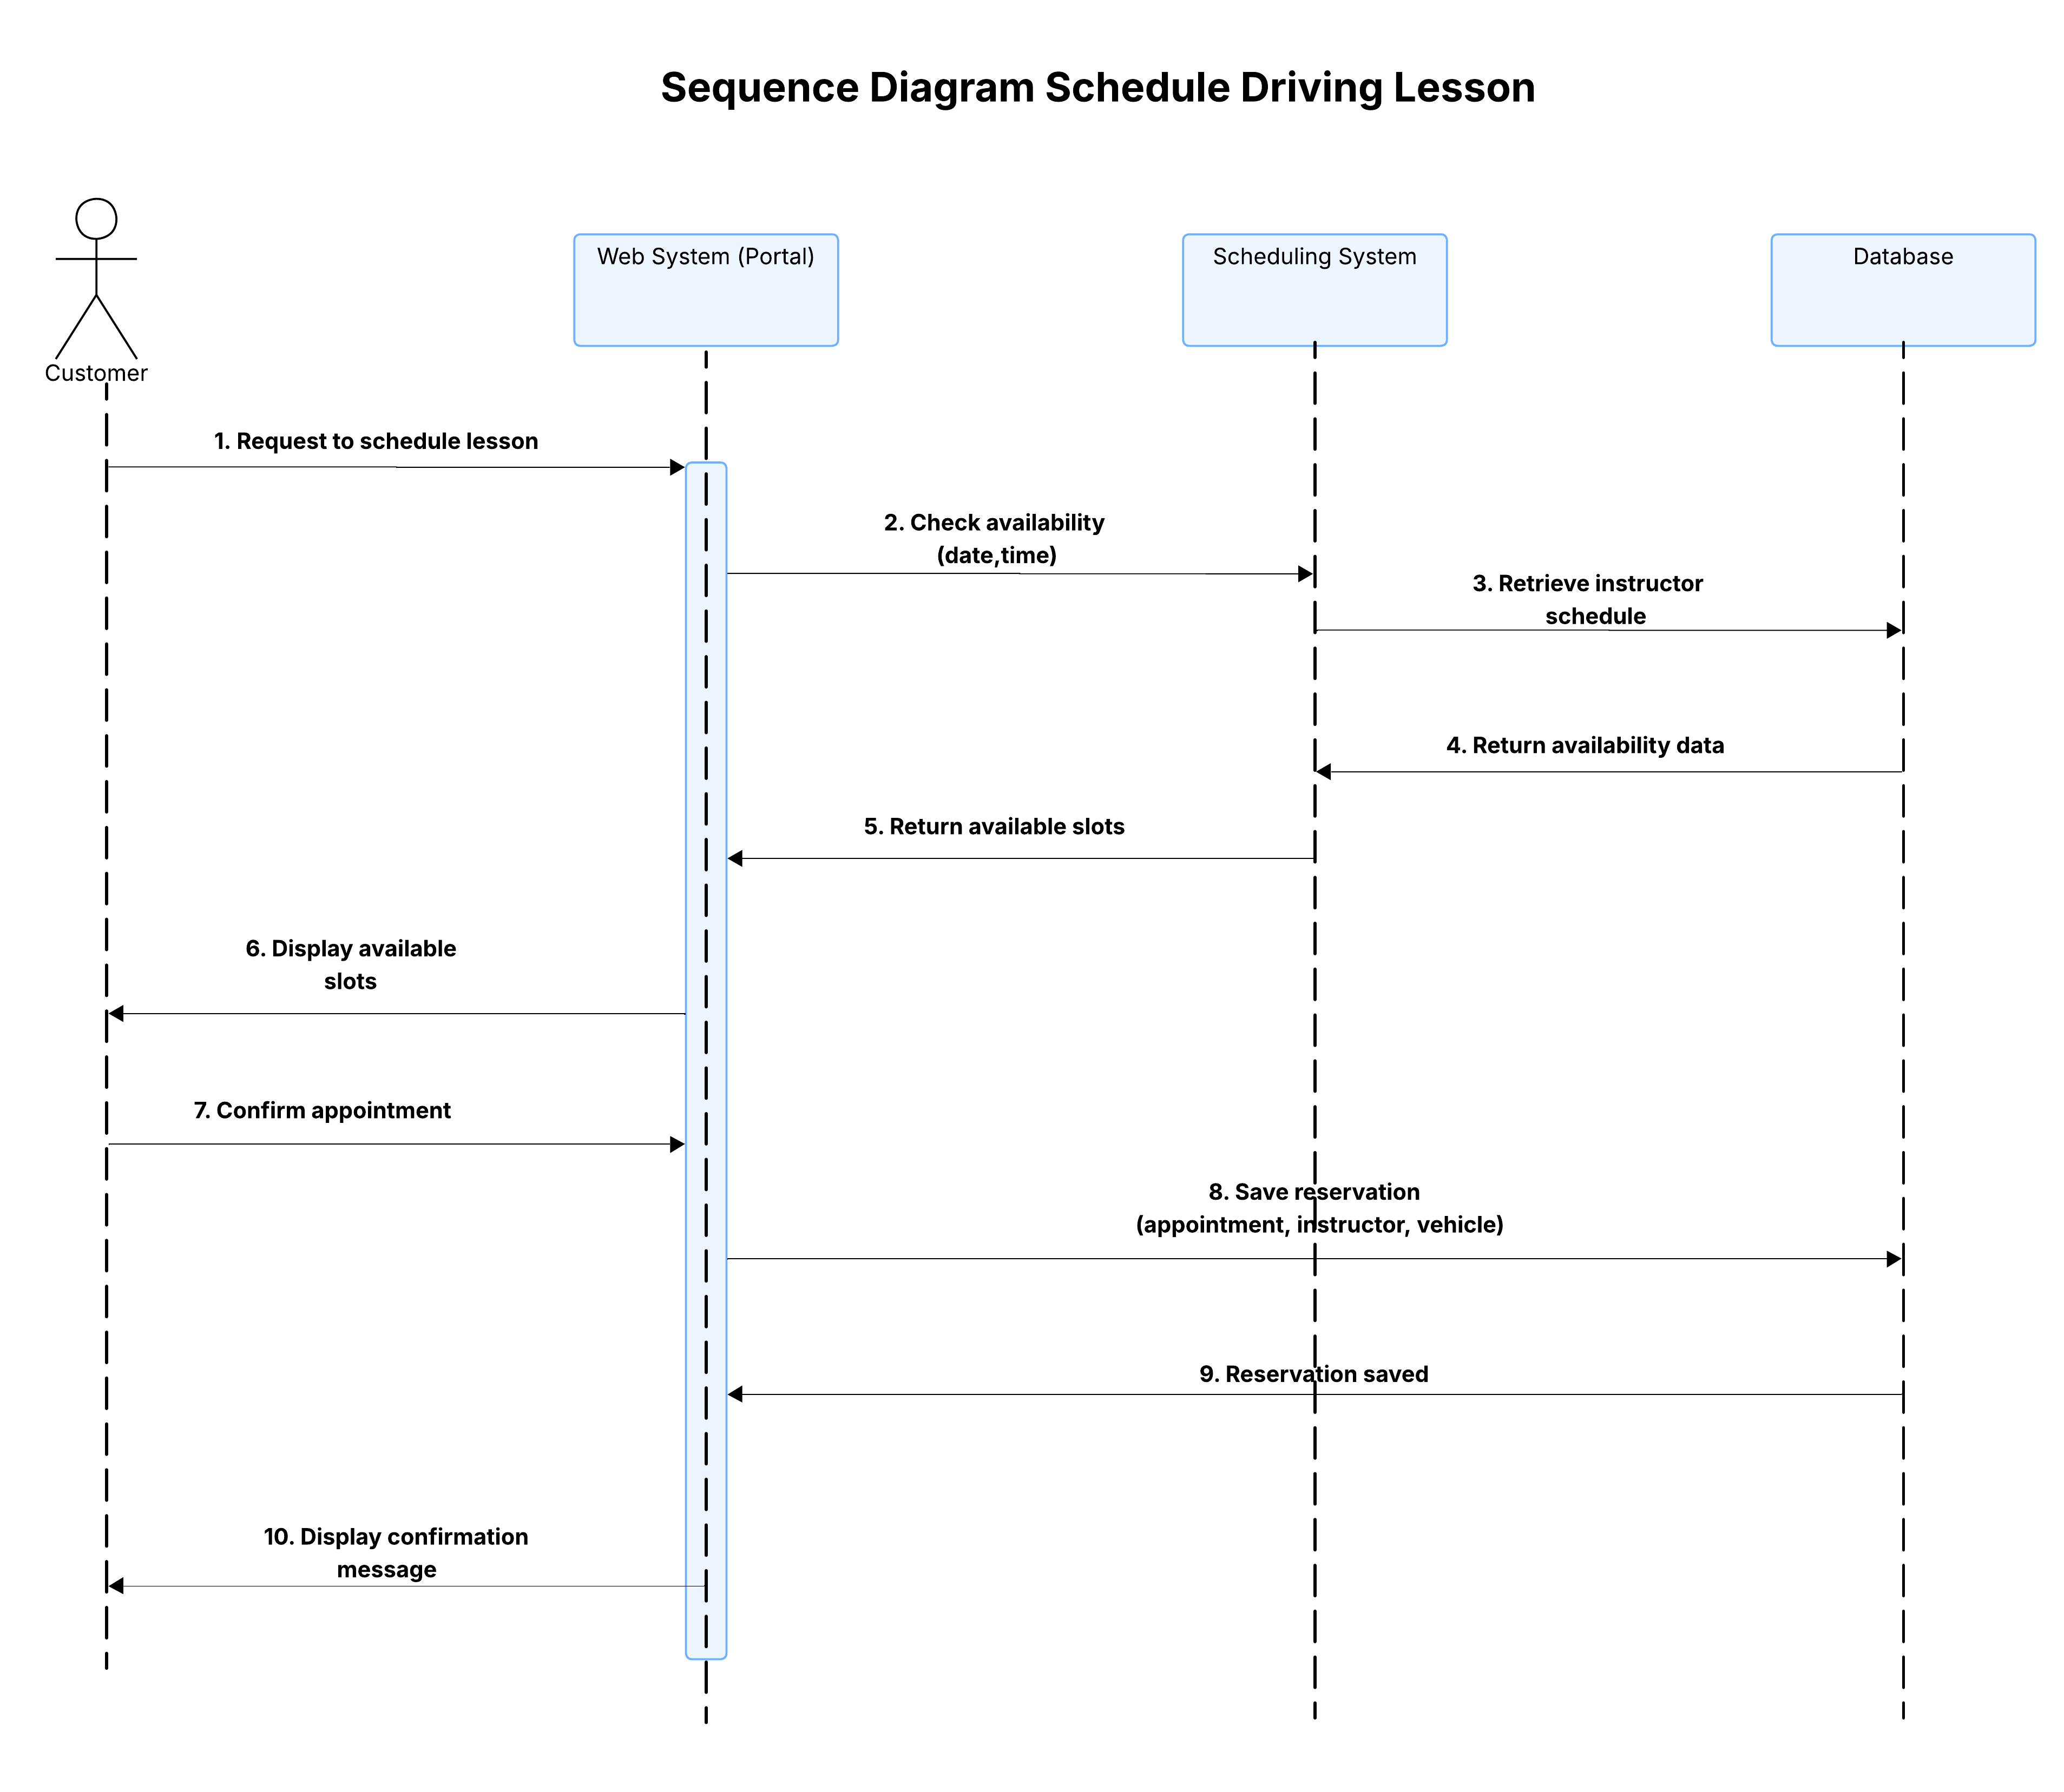

UML Class Diagram
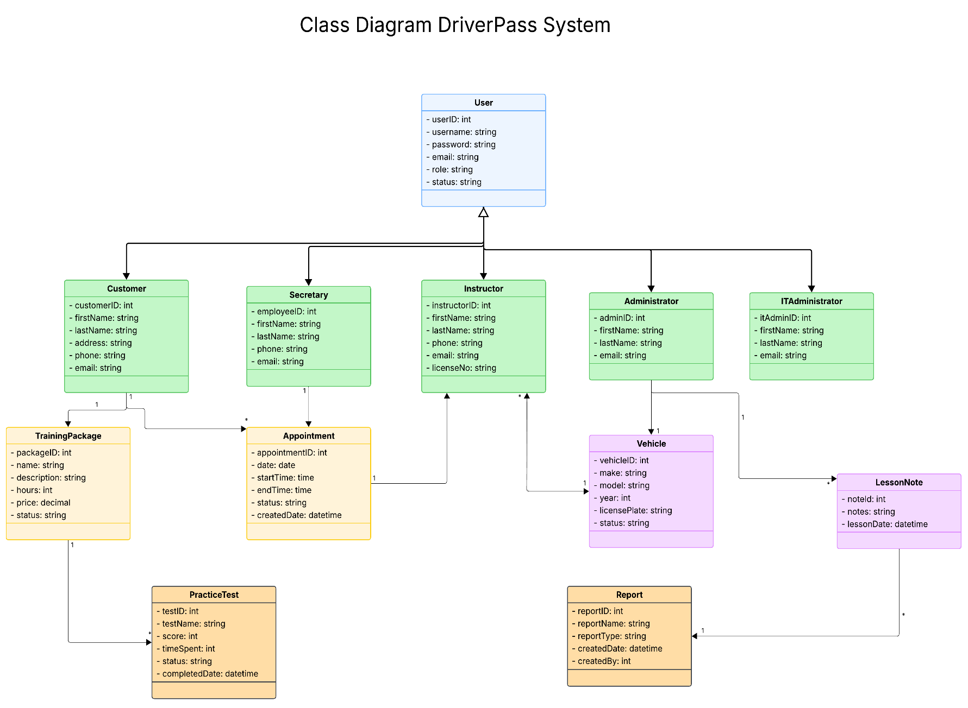

Technical Requirements
The DriverPass system will be a cloud-based web application that allows customers, instructors, secretaries, administrators, and IT staff to access the system from anywhere with an internet connection. This design provides flexibility for users while ensuring that important information is available when needed.
Hardware Requirements
- Computers, tablets, and smartphones that can run modern web browsers
- Cloud-based servers to store customer records, appointments, lesson details, and test results
- Reliable network infrastructure to support secure access to the system
- Backup storage provided through the cloud hosting service
Software Requirements
- Web browsers such as Google Chrome, Microsoft Edge, Mozilla Firefox, and Safari
- Cloud-based application software for DriverPass
- A database management system to store customer accounts, appointments, vehicles, instructor information, and test data
- Reporting tools to generate activity logs and management reports
Infrastructure Requirements
- A cloud hosting environment that supports system availability and future growth
- Secure internet connectivity between users and the DriverPass system
- A centralized database for storing customer and scheduling information
- Integration with DMV resources to keep driving regulations and practice test content up to date
Security Requirements
- Username and password authentication for all users
- Role-based access controls to limit access based on user responsibilities
- Password reset functionality for account recovery
- Encryption to protect sensitive customer information during transmission
- Activity logs to track account updates, appointment changes, and system access
- Account lockout protection after multiple failed login attempts
Performance Requirements
- The system shall support multiple users accessing the application at the same time.
- The system shall process appointment scheduling, cancellations, and modifications in real time.
- The system shall provide reliable access from computers, tablets, and mobile devices.
- The system shall maintain current DMV information through regular updates.

